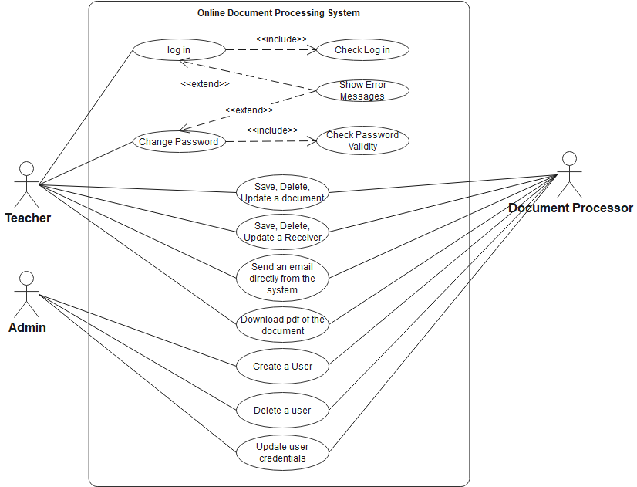

**Use Case UML Diagram For Online Document Processing System.**